NAME Treepat Chantaurai

DATE 11 December 2021 Section J

**Report Sheet for Experiment 15: Wave optics**

Abstract

In this experiment, the Bragg’s law as is investigated experimentally in four scenarios including single slit, double slit, multiple slits, and circular aperture. First, red laser light is passed through each slit and diffracts to a screen 1 meter away. The distance from the bright/dark spot (depending on each experiment) is measured from the central brightest spot. The value of is approximated to be which is the measured distance over the 1-meter screen distance. The diffraction equation is then confirmed by comparing the calculated laser wavelength to that of the theoretical one. The error turns to be -5.2%, 1.1%, 1.1%, 10.1%, respectively. Moreover, the shape of the aperture/slit shape is then varied to see its effect on the diffraction pattern. Increasing number of slit in multiple slits will create a sharper and more intense peak. Circular one shows alternating bright and dark rings which the diameter of first ring is used for calculation and that is inversely proportional to the radius of the aperture. The relationship is proved to be valid for circular aperture. The rectangular aperture shows pattern mimicking its aperture with the width and length proportional to the diameter of the first bright spot. This is also valid for the triangular aperture experiment.

Introduction and Theoretical Background

**Part I – Malus’ Law**

Natural light propagates in all directions as an unpolarized ray. Once it passes through a polarizer as in the Figure 1, only parallel component of it will transmit through as a polarized ray. If the angle between the polarizer and analyzer is , the penetrating electric field will be Ecos. With the intensity of the light directly proportional to the square of electric field. The final intensity as stated by Malus’ law would be

Figure 1 depicts the polarizer and the characteristic of light ray during polarization

**Part II – Single Slit Diffraction**

According to the Huygens principle, when the plane wave of light hit on the narrow slit. Every point on the plane of that narrow slit will be the sources for new wave. From above equation. With slit distance of a, the intensity can be derived as:

From this, the condition for destructive interference is

Figure 1 depicts interference of single slit experiment

**Part III – Double slit interference**

This happens when a plane of light is incident on the double slit and the bright constructive interference will be described as above as well as the intensity which has relationship depending on the distance and the wavelength.

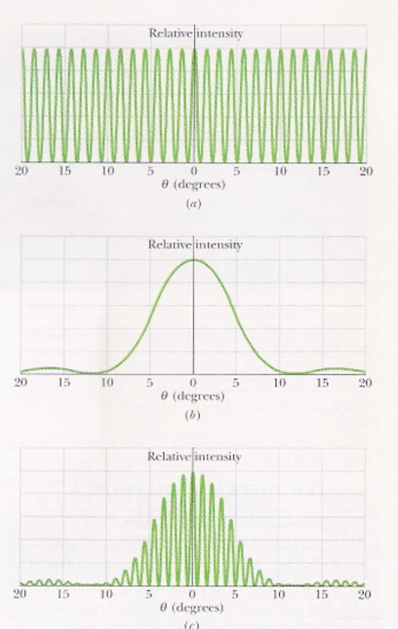

Figure 3 (a) depicts the infinitely small double slit without an effect from single slit diffraction (b) actual diffraction from a single slit and (c) double slit interference with an effect from single slit

**Part IV – Multiple slit**

This is an extension of a double slit experiment where the number of slits is increased to be N. If the distance between slits is d, the same relationship can still be acquired as to find the bright points as:

**Part V – Circular, Rectangular, and Triangular slits**

When a plane of light is incident to different shape of aperture like a circular one, a bright center can be observed surrounded by repeating rings of bright and dark spot. The first minimum of diffraction pattern is as follows.

Figure 4 depicts interference pattern from a circular aperture

Methods

All the experiments are done via simulation and the parameters used for each section are as follow. Images are saved from the simulation website without further modification. The large/major scale bar on each image corresponds to 1 mm. The distance between the slit and the screen is 1 m if not stated otherwise. Red laser light is used for all sections.

**Part I – Malus’ Law**

* This law is not experimented

**Part II – Single Slit Diffraction**

* Single slit is chosen with a distance between slit of 0.04 cm apart.

**Part III – Double slit interference**

* Single slit is chosen with 0.04 cm width and 0.08 cm slit distance

**Part IV – Multiple slit**

* Multiple slits is chosen of 8 slits with 0.08 cm distance

**Part V – Circular, Rectangular, and Triangular slits**

* Circular aperture is chosen with radius of 0.1 cm
* Triangular aperture is chosen with width of 0.04 cm
* Rectangular aperture is chosen with width and length of 0.08 cm

Results

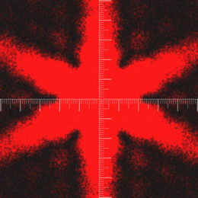

Figure 5 From top to bottom left to right are the diffraction pattern from each experiment (a) single slit with 0.04 distance (b) double slit with 0.04 width and 0.08 slit distance (c) multiple slits of 8 slits with 0.08 distance (d) circular aperture with 0.1 radius (e) triangular aperture with width of 0.04 and (f) rectangular aperture with height and width of 0.08. All are done at z distance of 1 m except the rectangular aperture which 2 m distance is used.

|  |  |  |  |  |  |  |
| --- | --- | --- | --- | --- | --- | --- |
| **Experiment** | **D (m)** | **Slit distance (m)** | **Number of slits** | **Distance between peaks (m)** | **Calculated Wavelength (nm)** | **%Error of wavelength (compared to 633 nm)** |
| Single slit | 1 | 0.0004 | 1 | 0.0015 | 600 | -5.2% |
| Double slit | 0.0008 | 2 | 0.0008 | 640 | 1.1% |
| Multiple slit | 0.0008 | 8 | 0.0008 | 640 | 1.1% |
| Circular aperture | 0.0010 (aperture) | - | 0.00085  (1st diameter) | 697 | 10.1% |

Table 1 summarizes parameters used in the experiment

Discussion

From the data calculated in the Table 1, all the wavelengths compared with the theoretical red laser light one yield only slight error. This confirms the validity of the diffraction pattern equations as can be demonstrated as follows.

* Single slit: 🡪 (0.0004 m)(0.0015 m / 1 m) = 1 x 🡪 = 600 nm [d is the midpoint of first bright spot]
* Double slit: 🡪 (0.0008 m)(0.0008 m / 1 m) = 1 x 🡪 = 640 nm [d is the midpoint of first dark spot]
* Multiple slit: 🡪 (0.0008 m)(0.0008 m / 1 m) = 1 x 🡪 = 640 nm [d is the midpoint of first bright spot]
* Circular aperture: 🡪 (0.00085 m / 1m) = 1.22 / (0.001 m) 🡪 = 697 nm [0.00085 is the diameter of first bright spot]

Moving to the next experiment of varying the shape of the slit aperture, the circular one shows circular rings of alternating bright and dark spots. In the same manner, the rectangular and triangular ones also show the alternating shape of bright and dark spots mimicking the shape of the slit’s aperture. The dimension of the central band in case of the rectangular aperture is related to the width and length of the aperture, on the other hand, the distance between each ban is inversely proportional to the slit dimensions.

In the case of multiple slits, various number of slits is done to compare their effects on the diffraction pattern as follows. They show not only sharper and more discrete pattern, but also have higher intensity as shown in figure 7.

Figure 6 depicts the multiple slit experiment with the number of slit as 4, 8, and 12

Figure 7 depicts the multiple slit experiment with their corresponding intensities

Conclusion

In conclusion, the Bragg’s law as is demonstrated experimentally in four scenarios including single slit, double slit, multiple slits, and circular aperture. First, red laser light is passed through each slit and diffracts to a screen 1 meter away. The distance from the bright/dark spot (depending on each experiment) is measured from the central brightest spot. The value of is approximated to be which is the measured distance over the 1-meter screen distance. The diffraction equation is then confirmed by comparing the calculated laser wavelength to that of the theoretical one. The error turns to be -5.2%, 1.1%, 1.1%, 10.1%, respectively. Moreover, the shape of the aperture/slit shape is then varied to see its effect on the diffraction pattern. Increasing number of slit in multiple slits will create a sharper and more intense peak. Circular one shows alternating bright and dark rings which the diameter of first ring is used for calculation and that is inversely proportional to the radius of the aperture. The relationship is proved to be valid for circular aperture. The rectangular aperture shows pattern mimicking its aperture with the width and length proportional to the diameter of the first bright spot. This is also valid for the triangular aperture experiment.

Reference

1. Lab manual titled “**Ch10.** **Measuring the earths magnetic field”**from Department of Physics on KLMS